Autobiography of Red

Group members: Sophie Rittenhouse, Tuan Nguyen, Antonio Mendez

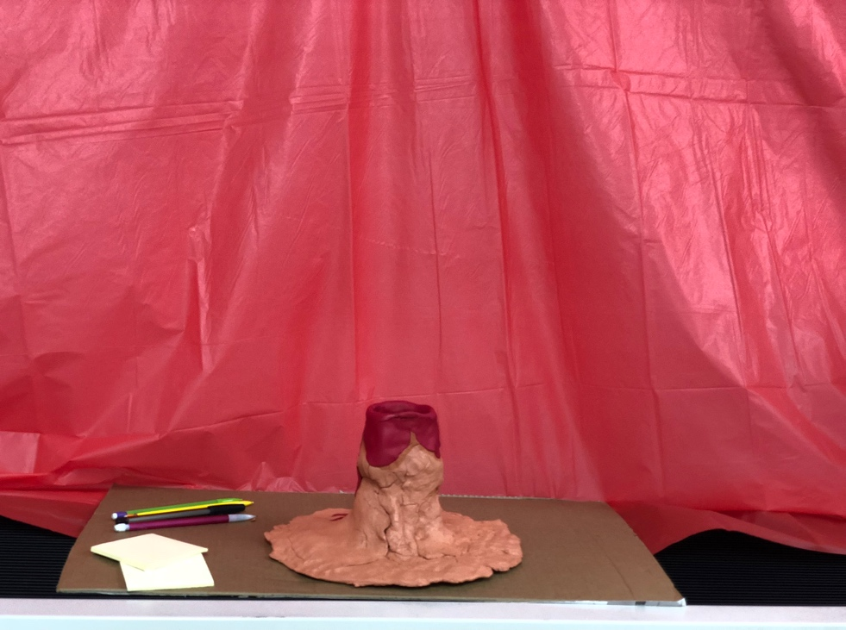

The Volcano we built out of burnt orange clay and red clay. We created an opening at the top to be part of our engagement piece. The volcano was dripping in red lava clay.

**Significance of the Volcano**: The volcano shows Geryon at the end of Autobiography of Red using his wings (whether physical or metaphorical) to jump into the volcano. This represented how Geryon faced his fears of being different and himself by taking a leap of faith. We chose to let our classmates “jump into the volcano” by writing down their own fears and placing them into the volcano. We did this by handing out post-it notes for each student to anonymously write on and drop into “the lava”. That was our way of letting those around us be vulnerable and face their fears just as Geryon did.

**Red Wall:** The significance of the red wall was that the book was entitled “Autobiography of Red”. We thought that the red background would draw attention and create a clear and common connection. Also, Geryon is a red winged monster and everything about him is red.

**Music Playlist:** Mixed songs that promote the feeling of sadness and motivation. We chose this music because sometimes listening to a sad song can help us connect into our emotions better. It made our space feel more open to emotion and encouraged our classmates to think.

Music Link: <https://youtu.be/9uIwT2BbCB0>

After we let our classmates engage with the space, we examined the list of fears and searched for links and connections.

**The class list of fears**

Failing class

Drowning

Skulls

Spiders - IIII

The dark

Not being happy

People knowing what my home life is like

Storms

Snakes

Not finding the job I love

Losing loved ones

Suffocating

Islamic fundamentalism

My mom dying - II

Police

Failure

Death

The future

This exercise showed how we all have different fears and that they are not always easy to admit or face, but it feels good to take the leap of faith.